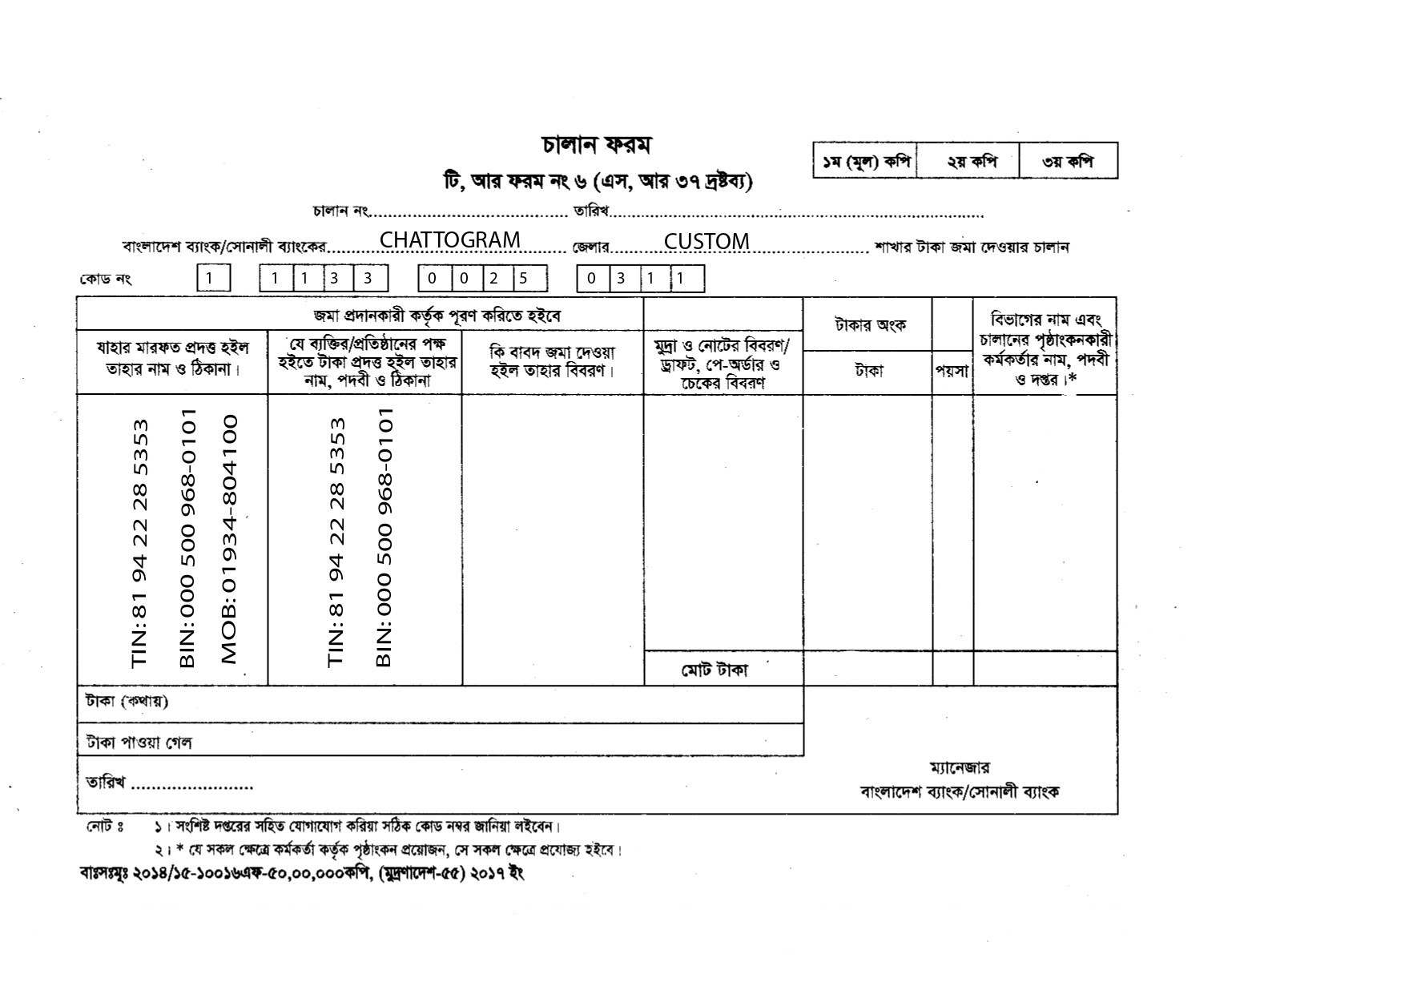

${day}/${month}/${year}

MV. ${vessel}  
  
 NRT: ${vsl_nrt} X 10/-  
 TK: ${amount} /-  
  
 15% VAT ON  
 LIGHT DUES   
   
 TK:${vat15}/- ${vat15}/-   
 ${amountinword}.

COMMENTS: 15% VAT ON LIGHT DUES OF MV. ${vessel}